**Huda Husain Petkar**

**M. Sc DS AI || L017 || ADBMS**

**Practical - 4**

**Date: 17.01.25**

**Aim: Indexing using MongoDB**

1. Mongo DB indexing

Cmd

mongosh

use students

db.createCollection("studentgrades")

db.studentgrades.insertMany(

[

{name: "Barry", subject: "Maths", score: 92},

{name: "Kent", subject: "Physics", score: 87},

{name: "Harry", subject: "Maths", score: 99, notes: "Exceptional Performance"},

{name: "Alex", subject: "Literature", score: 78},

{name: "Tom", subject: "History", score: 65, notes: "Adequate"}

]

)

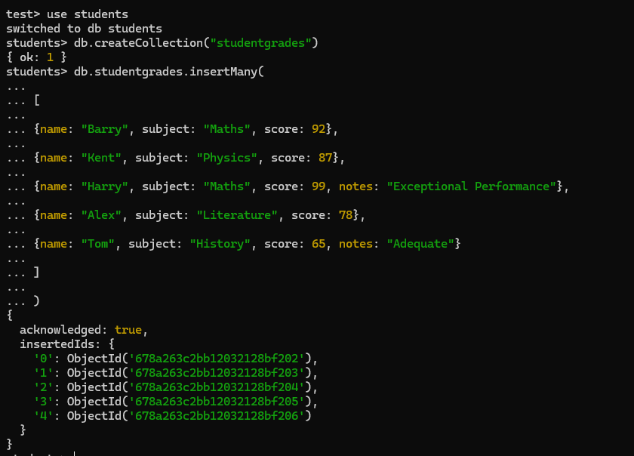

**a. Create index in Mongo DB**

db.studentgrades.createIndex( {name: 1}, {name: "student name index"} )



db.studentgrades.createIndex( {subject: 1}, {name: "subjects index"} )



db.studentgrades.createIndex( {score: -1}, {name: "scores"} ) // Creates an index in descending order



**b. Finding the indexes in a collection**

db.studentgrades.getIndexes()

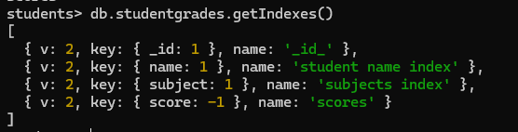

**c. Drop indexes in a collection**

Drop a single index using its name

db.studentgrades.dropIndex("scores")



**d. Drop all the indexes**

db.studentgrades.dropIndexes()

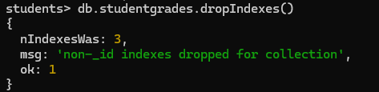

**—------------------------------ Creating Database using Compass —-----------------------------------**

Open MongoDB Compass

Connect

Click on the ‘+’ icon

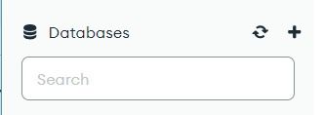

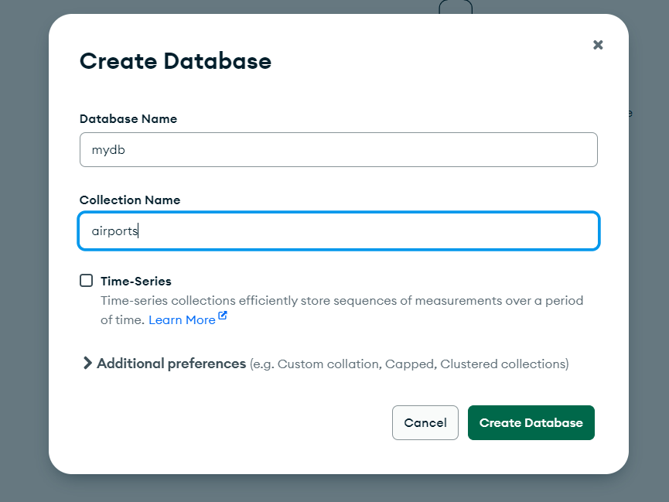

1. **To create Index**

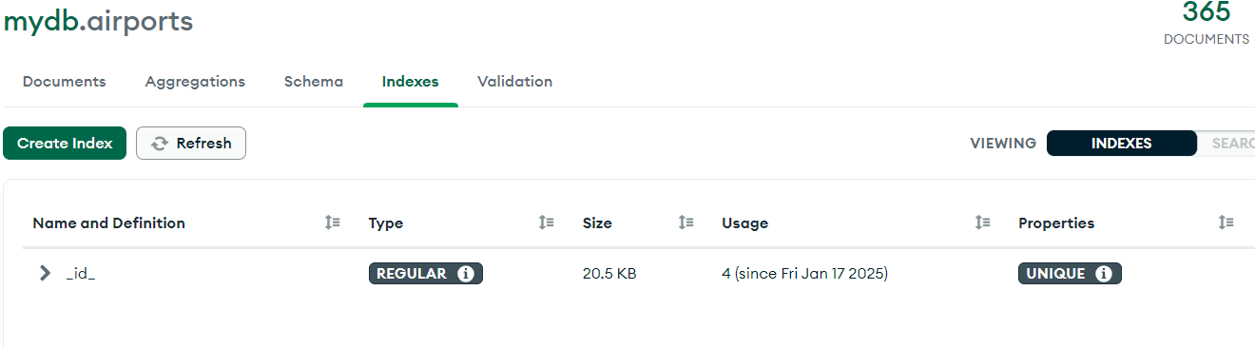

1. **Creating Index with name & sorting it in ascending order:**

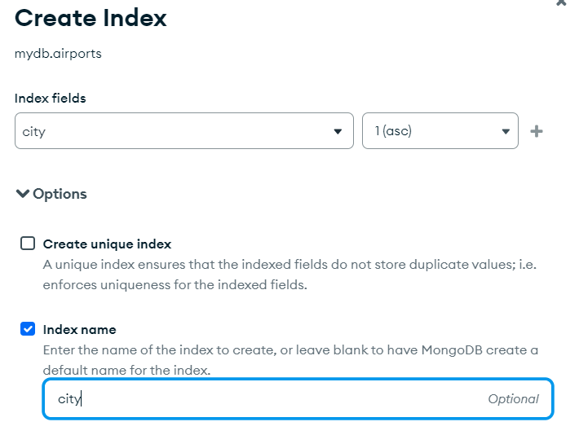

1. **Creating Index for name where we sort names in descending order**

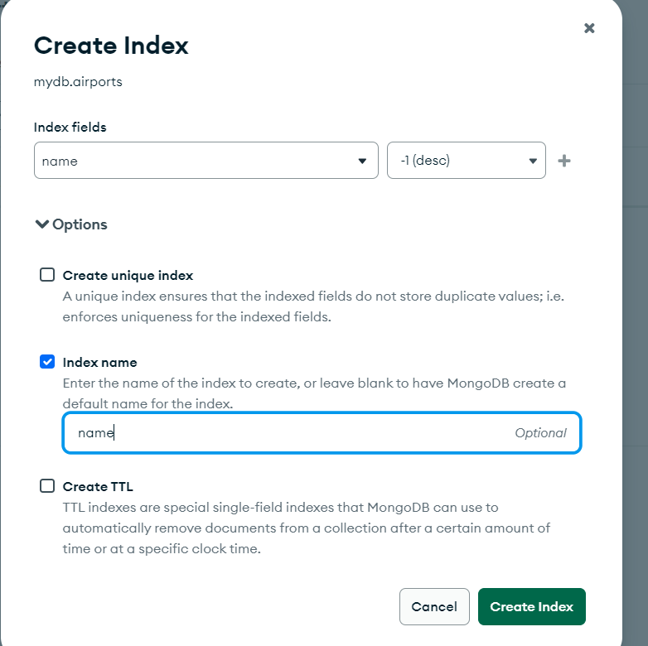

1. **Creating an Index for Airport_id & using Unique index**

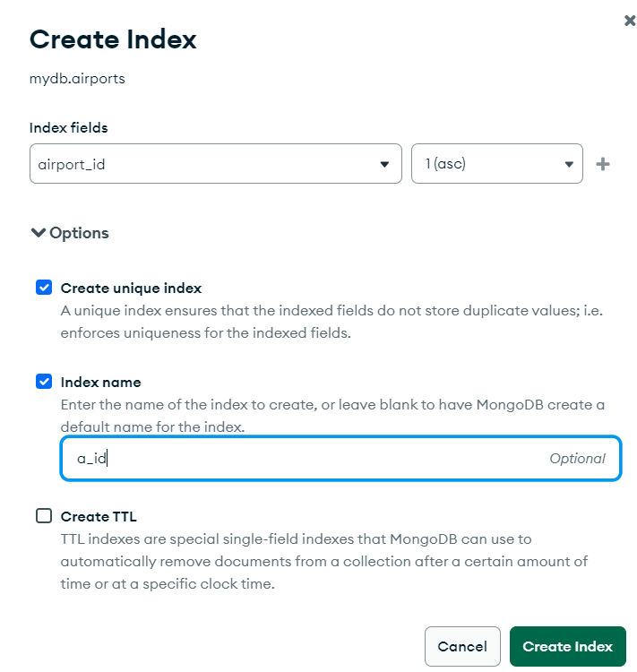

1. **Using TTL Index**

